Advanced Software System Lab

Assignment 1

Name-Bhavye Sharma

Roll no-171473

Batch-IT_61

Q1**WAP to add three numbers and print result. Also use Comments in the code.**

Ans

def sum_thrice(x, y, z):

sum = x + y + z

if x == y == z:

sum = sum * 3

return sum

print(sum_thrice(1, 3, 3))

print(sum_thrice(3, 2, 1))

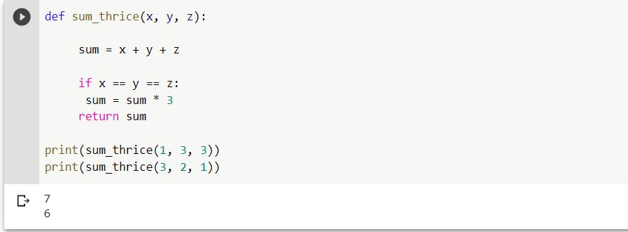

Q2. WAP to display your name & roll number in python.

def details():

    name, roll = "Bhavye Sharma", 171473

    print("Name: {}\nRollno:  {}".format(name, roll ))

details()

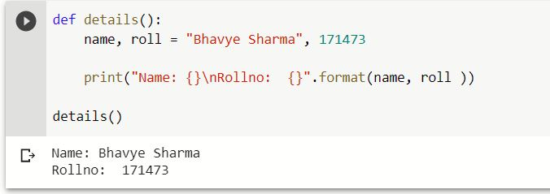

**Q3.** WAP to add three numbers, inputs from user and print result Try: In above program, give number in place of string and try to get the difference between input() and raw_input() function.

Ans3a.

a = int(input("Enter First No: "))

b = int(input("Enter Second No: "))

c=int(input("Enter Third No: "))

d = a + b +c

print (a, " + ", b,  " + ", c," --> ", d)

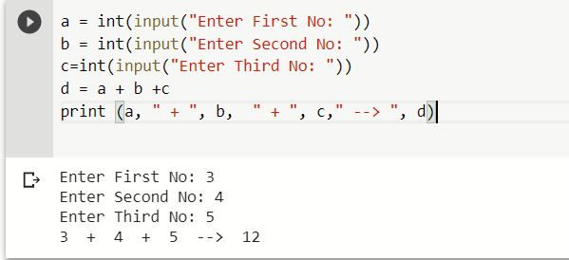

Ans3b.

a = input("Enter First String: ")

b = input("Enter Second String: ")

c = a + b   # concatinate two strings

print  (a, " + ", b, " --> ", c)

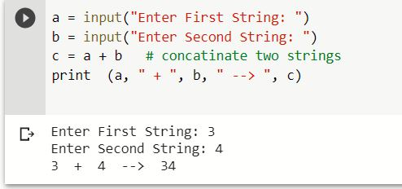

Q4. WAP to concatenate your first & last name. Take inputs from keyboard and then print

a = input("Enter First Name: ")

b = input("Enter Last Name: ")

c = a + b   # concatinate two strings

print  (a, " + ", b, " --> ", c)

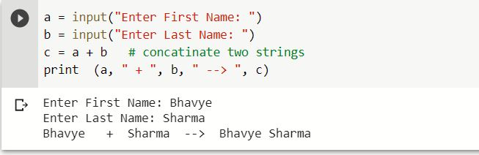

Q5. WAP to declare three variables x,y and z and assign the values 33, 17.5 and "Python" in one single line & print data type of each variable.

Ans-

x=33

y=17.5

z="Python"

print(type(x),type(y),type(z))

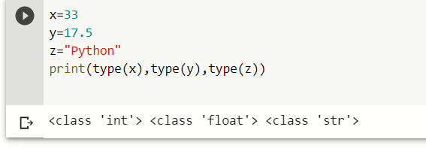

Q6.  WAP to convert an integer variable x=17 into complex number

Ans.

x=17

y=complex(x)

print(y)

